Caenorhabditis elegans (C. elegans)
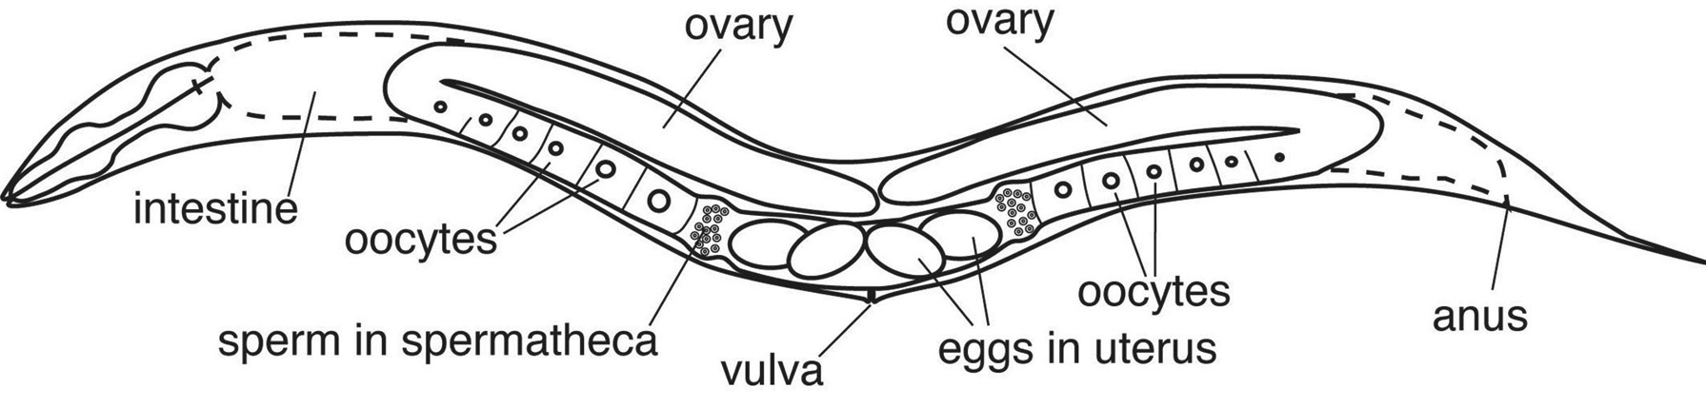

PLATE | MOVEMENT | SHAPE | SIZE | OTHER
A

B

C

D

E

Much of evolution is driven by mutations. A mutation occurs in the DNA code of a gene that can result in a change in the organism. Some of those changes result in better survivability of the organism. Most mutations within the gene sequence are not beneficial for the organism, however, these mutations are beneficial to a biologist. A gene mutation that causes a phenotypic change that can shed light onto the function of the gene product. Much of human genetics was understood from diseases which were known to be caused by a single gene mutation. Mutations can also be studied in model organisms, which allows researchers a better opportunity to control their experiment.

Today, you will look at four mutations and compare them to wildtype or “normal” (A). Describe what you see, observe movement, shape and size of the five different worms.
Do all of the worms have observable differences?

If not, then how do you know that there is a mutation in one of the genes of this worm?

If there is a mutation, what would you expect to be different in the mutant worm compared to the wildtype worm?

What can you do to test whether or not this worm is a mutant?

The genes which are mutated in the four C. elegan above are:
B is dpy-11
C is alx-1
D is unc-42
E is vps-29

Look up these gene names and determine what gene product the mutation is affecting. What is a gene product? Does the mutation fit the observed phenotypes you made? Are there any human homologs of these genes? If so what information can you find on the human homolog (i.e. does the mutation in that gene cause a disease?). What is a homolog?

You will test only the DNA of the mutant that does not have and observable phenotype, and compare this to the DNA of the wildtype. First you will extract the C. elegan DNA. What will you need to do next to compare the specific gene of these two C. elegan DNA?

DNA extraction of C. elegan

- Label a 0.2 ml PCR tube on the top of the tube.
- Add 100μl of C. elegan lysis buffer with proteinase K to the PCR tube. What is proteinase K?
- Add 500μl of sterile deionized water to the wildtype plate and to the mutant plate and swirl the water to mix in the worm. You may need to add more, if the plate is dry and absorbs all of the water, add more water. You should be able to swirl the worms on the plate with this liquid.
- Take 100μl of the worms/water mixture and add this to the PCR tube with the lysis buffer.
- Mix the tube by inverting 7 times.
- Put tubes into the -20°C freezer for 20 minutes.
- Lysis the C. elegan cells by heating them for 10 hours at 65°C with a 4°C storage, this can be accomplishes easily in a PCR machine using this cycle:
- Spin tubes to pellet cell debris 2 minutes in centrifuge and transfer 100μl of the supernatant to a new labeled 0.65 ml tube.
- DNA can be stored at 4°C.
PCR of mutant and wild type vsp29 gene

1. Mix each of the following into a PCR tube:
a. 10µl of GoTaq
b. 4.5µl of each of two primers (forward and reverse)
c. 1µl DNA extract

2. Mix the mixture by tapping on the PCR tube. Your total volume will be 20 µL.

3. Centrifuge briefly to pool the PCR ingredients if necessary.

4. Place the prepared PCR tube into the PCR machine and run using the following sequence:
a. Heat to 94º C for 2 minutes
b. 94º C for 30 seconds
c. Cool to 57º C for 30 seconds
d. Warm to 72º C for 1 minute
e. Repeat this sequence 30 times beginning at step b
f. Hold at 72º C for 3 minutes before taking to 4º C for storage

PCR Profile

Wild-type vs. Mutant PCR Product Prediction:

A mutation can be defined as a change in the DNA sequence, and usually compared to the “wild-type” lacking the DNA sequence change. This change in DNA sequence may or may not result in an observable phenotype. Mutations come in many different forms and sizes. Below are a few examples of mutations.

- A Substitution mutation is a mutation that exchanges one nucleotide for another (e.g. a single change from a A G). The mutant gene would be the same size as the wild-type gene. This mutation can result in a substantial change in the gene product and therefore the phenotype, or none at all. A Silent mutation is a DNA mutation that does not alter the gene product (i.e. RNA or Protein resulting from expression of that gene).

- An Insertion is a mutation which extra nucleotides are inserted into the new place in the gene, which could significantly alter the phenotype. This usually leads to a larger gene product depending on the location of the insertion. These mutations usually have a substantial affect on the protein produced, and more likely to have an observable phenotype.

- A Deletion is a mutation which sections of a gene are cut out of the DNA sequence. This usually leads to a truncated version of the gene product. These mutations also tend to have a substantial affect on the protein produced, and more likely to have an observable phenotype.

If you have a substitution mutation, your PCR product will not differ in size, you will need to sequence the DNA to confirm this mutation. On the next page you will predict the relative size of your PCR product, if you have a deletion or insertion mutation. Why would your PCR product differ in size with an insertion or deletion in you gene?

Predictions of Mutant Deletion

Draw a DNA representation of the forward  and reverse primers binding to the  Mutant DNA with a deletion  - Circle the region(s) of DNA where the deletion may be present | Draw the predicted PCR product on the DNA Electrophoresis Gel based on the  size of the mutant deletion  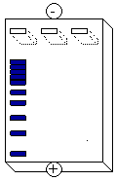  - Note the direction the DNA is moving  - Note the relative size of the PCR product

Predictions of Mutant Insertion
Draw a DNA representation of the forward  and reverse primers binding to the  Mutant DNA with a insertion  - Circle the region(s) of DNA where the insertion may be present | Draw the predicted PCR product on the DNA Electrophoresis Gel based on the  size of the mutant insertion  - Note the direction the DNA is moving  - Note the relative size of the PCR product

Gel Electrophoresis

Pouring an agarose gel

1. Get your electrophoresis apparatus and seal both ends of the gel tray with tape or stoppers.

2. Make sure one comb is in place at the negative electrode (black end of the gel).

3. Pour melted agarose into the gel space until the gel is about 5 mm deep. Let the agarose
harden, which should take 5-10 minutes. Don’t touch/move your gel until it’s hard. In the meantime, prepare your PCR reactions for electrophoresis.

Electrophoresis of your PCR reactions

- When your gel has hardened, remove the tape or stoppers.

- Load your samples into the wells - be sure you keep track of which samples you're loading in which wells Load 15µl of molecular weight marker into one of the electrophoresis gel wells. Load 15µl of the wild-type vsp29 PCR product into another well of the electrophoresis gel. Load 15µl of the mutant vsp29 PCR product into another well of the electrophoresis gel.

- Repeat step 2 and 3 (using sequential empty wells) until three group’s PCR samples have been loaded into the gel.

- Pour TAE buffer carefully so it fills the electrophoresis apparatus and just covers the gel.

- Run the electrophoresis approximately 30 minutes between about 125 V.

Staining gels to examine PCR reactions

- Place gel in staining tray and add TAE to the top of the gel so that there is liquid to help diffuse the ethidium bromide into the gel.

- Using gloves, remove the plastic from the ethidium bromide sheet and place the ethidium bromide paper on the gel. Gently rub the paper with your fingers to make sure it is contacting the gel all over. The paper should be completely wet, if not add more TAE to the top.

- Stain for about 10-15 minutes. While you are staining your gel, predict what you think you will see. Your prediction will be based on the hypothesis, which you developed in the prediction of mutations section above.

- Put the gel on the UV light box and, with the UV shield down, view your gel.

- Take a picture of your gel. Draw a picture of your gel:

What do you see on your gel? Were there any PCR fragment size differences? If there were, does the data support your hypothesis. If not, modify your hypothesis and think about how you would test this hypothesis.

