**Protein Analysis of Green Fluorescent Protein (GFP)**

**Introduction:** Green fluorescent protein (GFP), originally isolated from a jelly fish, has become a powerful and widely used tool in biotechnology research. As the name suggests, GFP is fluorescent, meaning that when the protein is excited by an energy source like ultraviolet (UV) light, it will glow. In this case, the fluorescence is a visible green (~500 nm). We can use this property to see when and where the protein is expressed by the presence of green, fluorescent light.

In this lab investigation, you will analyze the proteins present in your *E. coli* samples. This analysis can be done by migrating proteins through a gel and comparing their sizes in a process called **SDS-PAGE**, which stands for sodium dodecyl-sulfate polyacrylamide gel electrophoresis. The gel is made of polyacrylamide, different from DNA electrophoresis gels made of agarose. Proteins do not have a uniform charge like DNA (negatively charged), which is why it is important to coat the proteins with a buffer (SDS) so they will have a uniform mass-to-charge ratio. When SDS coats the proteins, it gives them a net negative charge in a way that the proportion of protein binding to SDS is relative to the protein’s molecular mass.

This activity will allow you to see the difference in cellular proteins in *E. coli* regulated to express GFP compared to cells that do not express the protein. First, you will extract all of the protein from the bacteria using a buffer that contains detergents to break open the cells, releasing the proteins. You will then determine the protein concentration of the samples to find out how much protein was extracted. The proteins will then be separated by size using SDS-PAGE. After running the gel, you can apply UV light to see if the band of green fluorescent protein reveals itself before staining the gel with a protein-specific stain (Coomassie blue) to visualize the separated proteins. Although you should only see one green, fluorescent band under UV light, the Coomassie-stained gel will allow you to see all of the extracted proteins separated by size so you can explore variation in protein profiles between different bacteria samples and different extraction conditions.

**Protein Extraction from Transformed *E. coli* Cells:**

1. Label a 1.7 mL tube containing 500 µL of LB broth as “G-“ for “green minus.” Label a second 1.7 mL tube containing 500 µL of LB broth as “W-“ for “white minus.”
2. Use a 10 µL loop to collect 3-4 green/glowing colonies from your transformed *E. coli* plate. Add these bacterial cells to the G- tube by inserting the loop into the LB broth and twisting the loop between your thumb and forefinger to dislodge the cells and mix the solution thoroughly.
3. Use a new 10 µL loop to collect 3-4 white/non-glowing colonies and add them to your W- tube by following the same loop-twisting procedure as in the previous step.
4. Label the G- and W- tubes with a group identifier and centrifuge them for 5 min at 13,000 rpm.
5. Without dislodging the pelleted cells, pour the liquid (called the supernatant) from each tube into a waste container.
6. Add 400 µL of protein extraction, or Camiolo, buffer to each tube. Vortex each tube for 1 min.
7. Label two new 1.7 mL tubes as “G+” for green plus heat and “W+” for white plus heat.
8. Transfer 200 µL of the mixture from the G- tube to the G+ tube. Transfer 200 µL from the W- tube to the W+ tube.
9. Leave the two “no heat” tubes (G- and W-) in a rack on your bench at room temperature while incubating the two “+ heat” tubes (G+ and W+) at 95°C for 5 min.
10. After heating, cool the tubes on the bench for 5 min and then centrifuge all four tubes for 3 min at 13,000 rpm to pellet the cellular debris.
11. For each sample, transfer the supernatant to a new, labeled 1.7 mL tube, taking care not to transfer any of the pelleted debris.

**Determining Protein Concentration:** In this section of the lab activity, two groups will work together to do a Bradford assay using protein standards of known concentration to determine the protein concentrations in your extracted samples.

1. Label the ribbed/rough side of one cuvette for each of your samples. The ribbed/rough side of the cuvette is labeled because the smooth side will face the light source in the spectrophotometer and should, therefore, not have any markings that could interfere with the light hitting the sample inside the cuvette.
2. Label the ribbed/rough side of eight cuvettes for the known concentrations of protein standards as shown in the figure below.

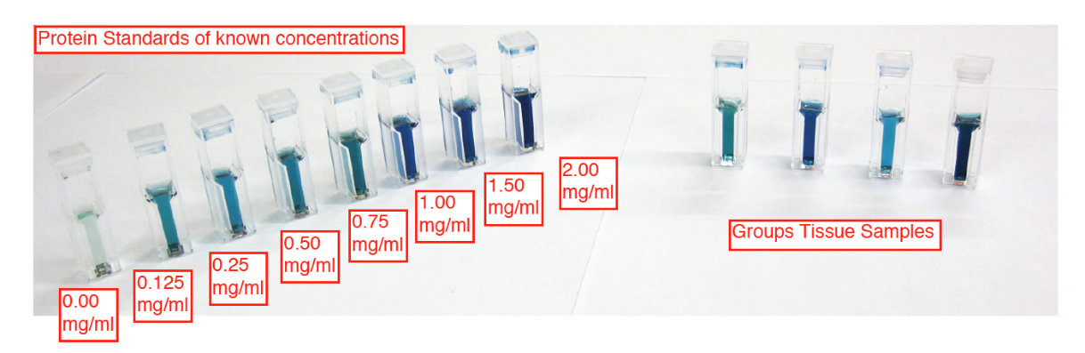

1. Add 1 mL of Bradford reagent to each cuvette.
2. Add 20 µL of each protein standard and extracted sample to its corresponding cuvette. Remember to use a new micropipette tip for each standard/sample.
3. Use cuvette lids or parafilm squares to cover the cuvettes prior to inverting them several times to mix the solutions thoroughly.
4. Allow the cuvettes to sit at room temperature for at least 5 min, but not longer than 1 hour.
5. Set the spectrophotometer to a wavelength of 595 nm. Use the 0.00 mg/mL standard cuvette to blank the spectrophotometer after wiping off the smooth sides of the cuvette with a Kim-Wipe (the smooth sides of the cuvette should line up with the light source of the spectrophotometer, which is often indicated with an arrow).
6. Measure the absorbance of the remaining protein standards and of your samples, remembering to wipe off the smooth sides of each cuvette with a Kim-Wipe before placing it in the spectrophotometer. Record the protein standard values in **Table** **1** and your sample values in **Table 2**.

**Table 1:** Bovine Serum Albumin (BSA) Protein Standard Absorbances at 595 nm

|  |  |
| --- | --- |
| BSA Protein Standard (mg/mL) | Absorbance (595 nm) |
| 0 (Blank) | 0 |
| 0.125 |  |
| 0.25 |  |
| 0.50 |  |
| 0.75 |  |
| 1.00 |  |
| 1.50 |  |
| 2.00 |  |

1. Use Excel (or a similar program) to make a scatter plot of absorbance values as a function of the protein concentration in the standards (i.e., the data from **Table 1**). Protein concentration (mg/mL) should be on the *x*-axis and absorbance (595 nm) on the *y*-axis. Add a “best fit” straight line to the graph and set the intercept to zero since zero protein should give zero absorbance. Insert the equation of the line, which should be in the format *y* = *mx*. If using Excel:
   1. Open an Excel spreadsheet and add your data from **Table 1**, using one column for protein standard concentration and another column for absorbance.
   2. Highlight the values, click on “Insert,” and choose the scatter plot chart option that does not have a line.
   3. Go to “Chart Design” > “Add Chart Element” > “Trendline” > “Linear” to add a trendline to your scatter plot.
   4. Right click on the trendline and select “Format Trendline.” In the window that opens on the right side of the screen, scroll down and select “Set Intercept” (it should automatically set to 0,0), and “Display Equation on Chart.”
2. Write down the equation of the trendline from your standard curve here: ____________

**Table 2:** Protein Sample Absorbances at 595 nm and Calculated Concentrations

|  |  |  |
| --- | --- | --- |
| Sample Name | Absorbance (595 nm) | Protein Concentration (mg/mL) |
|  |  |  |
|  |  |  |
|  |  |  |
|  |  |  |

1. Use this equation to determine the protein concentrations of your samples using the absorbances listed in **Table 2**; however, before doing your calculations, check your sample absorbance values against the highest absorbance that was measured for your protein standards (i.e., the absorbance for the 2.00 mg/mL standard). If the absorbance of your sample is greater than the maximum absorbance of the standard curve, then you will need to repeat the Bradford assay using less sample. In other words, you will need to dilute the sample before repeating the assay. If the absorbance of your sample falls within the range of the standard curve, then you do not need to repeat the assay with a diluted sample and can instead proceed to step 12.
   1. If the absorbance of your sample is not far beyond the range of your standard curve (e.g., <0.5 A beyond the maximum), then try a 1:4 dilution of the sample. To make a 1:4 dilution, mix 15 µL of the sample and 5 µL of Camiolo buffer (or water) with 1 mL of Bradford reagent.
   2. If the absorbance of your sample is greater than 0.5 A beyond the maximum absorbance of your standard curve, then try a 1:2 dilution by mixing 10 µL of the sample and 10 µL of Camiolo buffer (or water) with 1 mL of Bradford reagent.
2. For samples that fall within the range of your standard curve, use the measured absorbance value of the sample and the equation of the best fit line from your standard curve to calculate the concentration of protein in each sample. If you had to dilute the unknown (step 11), then you will need to correct your calculation for the dilution factor in order to determine the concentration of protein in your original sample. For example, if you made a 1:4 dilution of the original sample, then multiply your calculated concentration by 4 to “undo” the dilution. Record your calculated concentrations in **Table 2**.

**Sample Preparation for Gel Electrophoresis:** In order to load an equal amount of protein from each of your samples onto the SDS-PAGE gel, you will need to dilute your samples to the same concentration. The final concentration of all of your samples will be determined by the sample that had the lowest concentration (unless that concentration is less than 0.25 mg/mL). Extracted protein concentrations for this activity are usually between 0.8 and 1.5 mg/mL. If your samples are in or above this range, then dilute your samples to 0.5 mg/mL protein for the gel. If your lowest sample concentration is less than 0.25 mg/mL, then dilute the other samples to the next highest concentration (ideally 0.5 mg/mL). Sample dilutions will be made using Laemmli sample buffer, which has loading dye and other ingredients like the detergent SDS that will help denature the proteins and give them a net negative charge so they can be separated by size using SDS-PAGE. Below is an example calculation for diluting a 1.2 mg/mL protein sample, making 0.1 mL (or 100 µL) of a 0.5 mg/mL solution:

$$\left(Final Concentration\right)×\left(Final Volume\right)=\left(Sample Concentration\right)×\left(Sample Volume\right)$$

$$\frac{\left(Final Concentration\right)×\left(Final Volume\right)}{Sample Concentration}=Sample Volume$$

$$\frac{\left(0.5 mg/mL\right)×\left(0.1 mL\right)}{1.2 mg/mL}=Sample Volume$$

$$Sample Volume=0.0417 mL=41.7 µL$$

$$Volume of Laemmli Buffer Needed=100 µL-41.7 µL=58.3 µL$$

For each of your samples, use the above example as a guide to calculate how much of the sample you need to mix with how much Laemmli buffer to make 100 µL of a 0.5 mg/mL solution (or whatever concentration makes sense for your samples). Add these volumes to **Table 3**.

**Table 3:** Sample and Laemmli Buffer Volumes to Make Dilutions for SDS-PAGE

|  |  |  |  |  |
| --- | --- | --- | --- | --- |
| Sample Name | Starting Protein Concentration (mg/mL) | Final Protein Concentration (mg/mL) | Volume of Sample Needed (µL) | Volume of Laemmli Needed (µL) |
|  |  |  |  |  |
|  |  |  |  |  |
|  |  |  |  |  |
|  |  |  |  |  |

1. Label a new 1.7 mL tube for each of your samples.
2. Make 100 µL of a 0.5 mg/mL dilution for each of your samples using the calculated volumes of sample and Laemmli buffer listed in **Table 3**.

**Sodium Dodecyl-Sulfate Polyacrylamide Gel Electrophoresis (SDS-PAGE):**

1. Inside the vertical gel box is the electrode assembly – take it out of the gel box.
2. 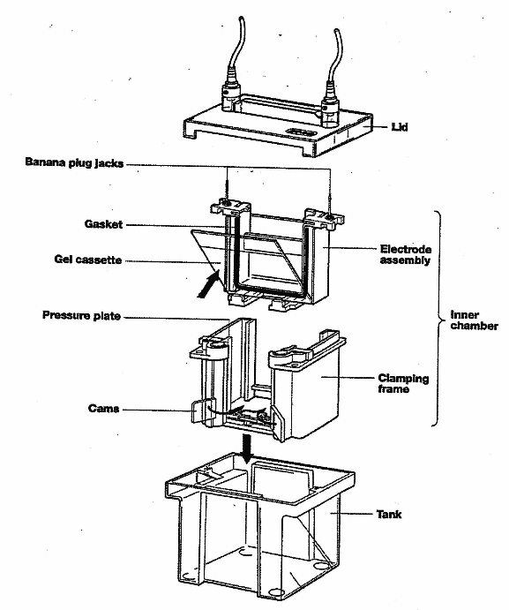On one side of the assembly is a plastic buffer dam. If you are running one gel in the electrode assembly, leave the dam in place. If you are running two gels, remove the dam, but **do NOT throw the dam away!**
3. Diagram

   Description automatically generatedPut on gloves and open the package holding your gel. The gel has a comb that was used to form the wells, but the comb needs to be removed. Carefully pull the comb straight out to remove it. There is also a piece of green tape on the bottom of the gel cassette that needs to be removed or else it will prevent the gel from running evenly.
4. Open the green sides of the electrode assembly. Place the gel cassette into the assembly so you can see the numbers written correctly from the outside of the assembly; the orientation of the cassette is critical to preventing buffer leaks when running the gel. If you are running one gel per box, make sure the buffer dam is placed correctly on the other side of the assembly. If you are running two gels in the box, place a second gel in the same orientation (i.e., so the numbers are written correctly when viewed from the outside of the assembly) on the other side of the electrode assembly. Close the green sides of the assembly, making sure they are tightly closed (e.g., push firmly in on both sides and then push in at the top and bottom of each green piece to make sure they cannot be pushed in any farther).
5. Place the electrode assembly into the gel box in the correct orientation of the electrodes needed for the gel box lid (you can put the lid on temporarily to make sure the assembly is in the correct orientation). Fill the inside of the electrode assembly to the top with 1X Tris-glycine-SDS buffer and check to make sure the assembly is not leaking at the bottom. If it is leaking, try to close the green sides of the assembly more firmly without spilling the buffer. When ready, fill the gel box outside of the assembly up to the appropriate line (2 gel or 4 gel) with 1X Tris-glycine-SDS buffer.
6. When these gels are made, some of the reagents will remain at the bottom of the wells, which can interfere with running your protein samples. Rinse out the gel wells with buffer by using a gel loading tip and a micropipette set to 30 µL or higher to “pump” buffer from inside the gel cassette into each well (two or three “pumps” should be enough).
7. Load the gel with your protein samples – two groups will share one gel. First load 5 µL of the protein ladder and then load 30 µL of each of your protein samples if they are at 0.5 mg/mL. Remember to write down which sample is in which lane of the gel.
   1. If the concentration of your samples is less than 0.25 mg/mL, then you will not be able to load enough total volume to get to an equivalent of 30 µL of 0.5 mg/mL protein on the gel. Instead, you can try to load as much of your sample as possible onto the gel without the sample spilling into the next well. Each well can only hold a maximum of 50 µL, but eject the sample very slowly into the well if loading this much volume.
8. A picture containing electronics

   Description automatically generatedPut the lid on the gel box and plug the box into the power supply. Set the power supply to 150 volts and start the run. If your protein ladder is prestained, then watch it to know when to stop the gel. The smallest molecule of the protein ladder should be about 1.5 centimeters from the bottom of the gel (about 45-60 minutes). If the ladder is not prestained, then monitor the progression of the gel with the dye front and stop the gel just before the dye front runs off the gel.
9. To stop the gel from running, turn off the power supply, take the gel box lid off, and remove the gel from the electrode assembly by first pouring the buffer into the gel box and then opening the green sides of the assembly.
10. Before going any further, lay the gel cassette down on the counter with the numbers written correctly from left to right. Using a UV light, look for the glowing bands of GFP on the gel. You may need to turn the lights off to see it. If you see a green band light up, then this is the properly folded GFP (think about what properly folded means in terms of the ability to glow). Take a picture or take note of which band(s) is(are) glowing. Also, make note as to the approximate size based on comparison to the protein ladder (see figure on next page).
11. Diagram

    Description automatically generatedOpen the gel cassette and, very carefully, separate the two halves of the casing following the steps shown in the figure at right. Be careful with the gel – it is thin and very easy to tear! The gel will usually stay on one side of the casing and the bottom will curl up, making a good place to gently pull the gel up off the plate and place it into a staining tray.
12. Pour enough Coomassie blue stain into the staining tray to cover the gel completely. Be careful with the gel stain as it will also stain your skin, clothes, etc.
13. Cover your gel and stain it for at least 30 minutes; if you cannot see any protein bands after 30 minutes, continue to stain your gel until you do. Alternatively, you can leave your gel in the stain overnight.
14. After staining, your protein bands may be robust enough to view on a white light box for analysis without needing to destain the gel (if so, proceed to the next step). However, you can increase the contrast between the protein bands and the surrounding gel for easier analysis by destaining the gel in water. To do so, use gloved hands to prevent your gel from coming out of the staining tray while pouring off the Coomassie blue stain (the stain is drain safe). Rinse the gel and the tray with water and pour off the rinse. Add enough water to the staining tray to cover your gel completely (the more water, the faster the gel will destain, but be careful not to overfill the tray, especially if you will be using an orbital shaker to make the destaining process more efficient). Your gel should be sufficiently destained overnight, but you can leave it in the water for several days without affecting the protein bands.
15. Place your gel on a white light box for examination.

**Analysis:** Remember that the distance the protein band has traveled is related to the size of the protein. The known sizes of the protein bands in the ladder, labelled in the figure at right, can be used to estimate the sizes of the protein bands in your samples. Also, because you loaded the same amount of all of your samples (i.e., 30 µL of 0.5 mg/mL, or 0.015 mg total protein), how dark a band is relates to the concentration of protein – the darker the band, the more of that protein there is in the sample. There may actually be several different proteins of similar enough size that they are found in what appears to be one band on the gel; however, without further analysis with more advanced separation techniques (e.g., that use both size and electrical charge), we cannot tell how many proteins are really found in one band.

How many green fluorescent bands did you see? Why do you think that is?

What is the approximate size of GFP?

Did you find that GFP was expressed in all your samples? Why or why not?