**Protein Profile Comparisons using SDS-PAGE**

**Protein Extraction:**

1. Label one sample buffer tube for each of the four tissues your group will be using. These sample buffer tubes each contain 500 µL of protein extraction, or Camiolo, buffer.
2. Place approximately 0.1 g of your tissue sample (approximately the size of a pencil eraser) into its corresponding sample buffer tube. Make sure the tissue sample is submerged in the buffer.
3. Homogenize your tissue sample for approximately 1 minute. Let the sample tube sit at room temperature for 5 minutes, agitating periodically by inverting the tube several times (make sure the tissue sample is submerged in the buffer after inverting).
4. Label two new 1.7 mL tubes for each of your tissue samples.
5. Transfer 100 µL of sample liquid into each of the two corresponding, newly labeled 1.7 mL tubes. Do not transfer any solid tissue material.
6. To one of the tubes for each tissue sample, add 100 µL of Camiolo buffer. This addition will dilute the extracted sample by half. When you are finished, you should have two tubes for each sample – one with 100 µL of the original protein extract and one with 200 µL of diluted protein extract. You will use the diluted sample for measuring the concentration of protein using a Bradford assay. Set the undiluted sample tube aside in case you end up needing a more concentrated sample for analysis.

**Determining Protein Concentration:** In this section of the lab activity, two groups will work together to do a Bradford assay using protein standards of known concentration to determine the protein concentrations in your extracted tissue samples.

1. Label the ribbed/rough side of one cuvette for each of your tissue samples. The ribbed/rough side of the cuvette is labeled because the smooth side will face the light source in the spectrophotometer and should, therefore, not have any markings that could interfere with the light hitting the sample inside the cuvette.
2. Label the ribbed/rough side of eight cuvettes for the known concentrations of protein standards as shown in the figure below.

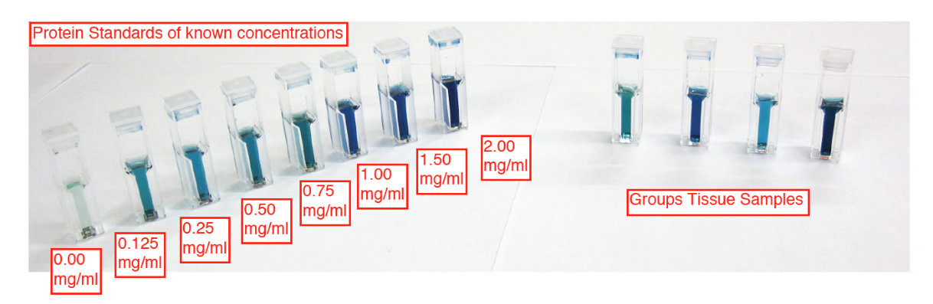

1. Add 1 mL of Bradford reagent to each cuvette.
2. Add 20 µL of each protein standard and tissue sample to its corresponding cuvette. Remember to use a new micropipette tip for each standard/sample.
3. Use cuvette lids or parafilm squares to cover the cuvettes prior to inverting them several times to mix the solutions thoroughly.
4. Allow the cuvettes to sit at room temperature for at least 5 minutes, but not longer than 1 hour.
5. Set the spectrophotometer to a wavelength of 595 nm. Use the 0.00 mg/mL standard cuvette to blank the spectrophotometer after wiping off the smooth sides of the cuvette with a Kim-Wipe (the smooth sides of the cuvette should line up with the light source of the spectrophotometer, which is often indicated with an arrow).
6. Measure the absorbance of the remaining protein standards and of your tissue samples, remembering to wipe off the smooth sides of each cuvette with a Kim-Wipe before placing it in the spectrophotometer. Record the protein standard values in **Table** **1** and your tissue sample values in **Table 2**.

**Table 1:** Bovine Serum Albumin (BSA) Protein Standard Absorbances at 595 nm

|  |  |
| --- | --- |
| BSA Protein Standard (mg/mL) | Absorbance (595 nm) |
| 0 (Blank) | 0 |
| 0.125 |  |
| 0.25 |  |
| 0.50 |  |
| 0.75 |  |
| 1.00 |  |
| 1.50 |  |
| 2.00 |  |

1. Use Excel (or a similar program) to make a scatter plot of absorbance values as a function of the protein concentration in the standards (i.e., the data from **Table 1**). Protein concentration (mg/mL) should be on the *x*-axis and absorbance (595 nm) on the *y*-axis. Add a “best fit” straight line to the graph and set the intercept to zero since zero protein should give zero absorbance. Insert the equation of the line, which should be in the format *y* = *mx*. If using Excel:
   1. Open an Excel spreadsheet and add your data from **Table 1**, using one column for protein standard concentration and another column for absorbance.
   2. Highlight the values, click on “Insert,” and choose the scatter plot chart option that does not have a line.
   3. Go to “Chart Design” > “Add Chart Element” > “Trendline” > “Linear” to add a trendline to your scatter plot.
   4. Right click on the trendline and select “Format Trendline.” In the window that opens on the right side of the screen, scroll down and select “Set Intercept” (it should automatically set to 0,0), and “Display Equation on Chart.”
2. Write down the equation of the trendline from your standard curve here: ____________

**Table 2:** Tissue Protein Sample Absorbances at 595 nm and Calculated Concentrations

|  |  |  |
| --- | --- | --- |
| Sample Name | Absorbance (595 nm) | Protein Concentration (mg/mL) |
|  |  |  |
|  |  |  |
|  |  |  |
|  |  |  |

1. Use this equation to determine the protein concentrations of your tissue samples using the absorbances listed in **Table 2**; however, before doing your calculations, check your tissue absorbance values against the highest absorbance that was measured for your protein standards (i.e., the absorbance for the 2.00 mg/mL standard). If the absorbance of your tissue sample is greater than the maximum absorbance of the standard curve, then you will need to repeat the Bradford assay using less sample. In other words, you will need to dilute the tissue sample before repeating the assay. If the absorbance of your tissue sample falls within the range of the standard curve, then you do not need to repeat the assay with a diluted sample and can instead proceed to step 12.
   1. If the absorbance of your tissue sample is not far beyond the range of your standard curve (e.g., <0.5 A beyond the maximum), then try a 1:4 dilution of the sample. To make a 1:4 dilution, mix 15 µL of the tissue sample and 5 µL of Camiolo buffer (or water) with 1 mL of Bradford reagent.
   2. If the absorbance of your tissue sample is greater than 0.5 A beyond the maximum absorbance of your standard curve, then try a 1:2 dilution by mixing 10 µL of the tissue sample and 10 µL of Camiolo buffer (or water) with 1 mL of Bradford reagent.
2. For samples that fall within the range of your standard curve, use the measured absorbance value of the tissue sample and the equation of the best fit line from your standard curve to calculate the concentration of protein in each sample. If you had to dilute the unknown (step 11), then you will need to correct your calculation for the dilution factor in order to determine the concentration of protein in your original sample. For example, if you made a 1:4 dilution of the original sample, then multiply your calculated concentration by 4 to “undo” the dilution. Record your calculated concentrations in **Table 2**.

**Sample Preparation for Gel Electrophoresis:** In order to load an equal amount of protein from each of your tissue samples onto the SDS-PAGE gel, you will need to dilute your samples to the same concentration. You will be using a final concentration of 1 mg/mL protein for the gel. Your samples will be diluted to this concentration using Laemmli sample buffer, which has loading dye and other ingredients like the detergent SDS that will help denature the proteins and give them a net negative charge so they can be separated by size using SDS-PAGE. Below is an example calculation for diluting a 3 mg/mL protein sample, making 0.1 mL (or 100 µL) of a 1 mg/mL solution:

$$\left(Final Concentration\right)×\left(Final Volume\right)=\left(Sample Concentration\right)×\left(Sample Volume\right)$$

$$\frac{\left(Final Concentration\right)×\left(Final Volume\right)}{Sample Concentration}=Sample Volume$$

$$\frac{\left(1 mg/mL\right)×\left(0.1 mL\right)}{3 mg/mL}=Sample Volume$$

$$Sample Volume=0.0333 mL=33.3 µL$$

$$Volume of Laemmli Buffer Needed=100 µL-33.3 µL=66.7 µL$$

For each of your tissue samples, use the above example as a guide to calculate how much of the sample you need to mix with how much Laemmli buffer to make 100 µL of a 1 mg/mL solution. Add these volumes to **Table 3**. If any of your samples have a concentration less than 1 mg/mL, then we will compensate for this lower concentration by adding more protein to the gel as described in the next section of the lab activity.

**Table 3:** Sample and Laemmli Buffer Volumes to Make 1 mg/mL

|  |  |  |  |  |
| --- | --- | --- | --- | --- |
| Sample Name | Starting Protein Concentration | Final Protein Concentration | Volume of Sample Needed | Volume of Laemmli Needed |
|  |  | 1 mg/mL |  |  |
|  |  | 1 mg/mL |  |  |
|  |  | 1 mg/mL |  |  |
|  |  | 1 mg/mL |  |  |

1. Label a new 1.7 mL tube for each of your tissue samples.
2. Make 100 µL of a 1 mg/mL dilution for each of your samples using the calculated volumes of tissue sample and Laemmli buffer listed in **Table 3**.
3. Incubate the tubes at 95°C for 5 minutes in order to denature the extracted proteins. After incubation, the samples can be loaded on the gel or they can be stored at -20°C. If stored, they will need to be incubated at 95°C for 5 minutes again prior to loading them on the gel.

**Sodium Dodecyl-Sulfate Polyacrylamide Gel Electrophoresis (SDS-PAGE):**

1. If samples are frozen, thaw them at room temperature before incubating them at 95°C for 5 minutes to denature the proteins.
2. Inside the vertical gel box is the electrode assembly – take it out of the gel box.
3. 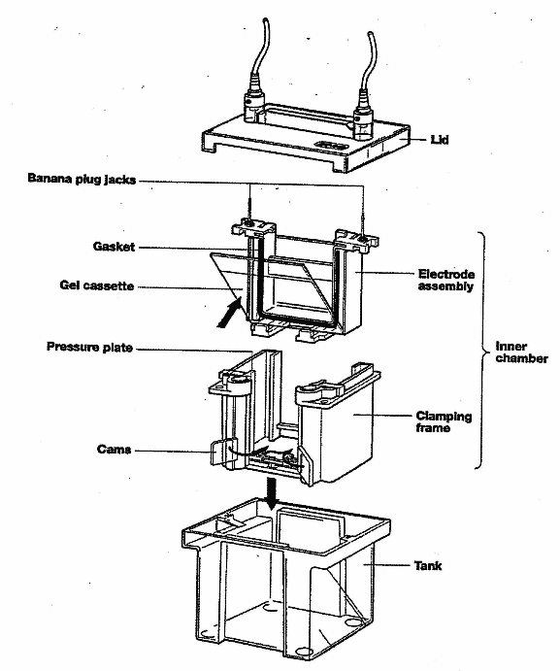On one side of the assembly is a plastic buffer dam. If you are running one gel in the electrode assembly, leave the dam in place. If you are running two gels, remove the dam, but **do NOT throw the dam away!**
4. Diagram

   Description automatically generatedPut on gloves and open the package holding your gel. The gel has a comb that was used to form the wells, but the comb needs to be removed. Carefully pull the comb straight out to remove it. There is also a piece of green tape on the bottom of the gel cassette that needs to be removed or else it will prevent the gel from running evenly.
5. Open the green sides of the electrode assembly. Place the gel cassette into the assembly so you can see the numbers written correctly from the outside of the assembly; the orientation of the cassette is critical to preventing buffer leaks when running the gel. If you are running one gel per box, make sure the buffer dam is placed correctly on the other side of the assembly. If you are running two gels in the box, place a second gel in the same orientation (i.e., so the numbers are written correctly when viewed from the outside of the assembly) on the other side of the electrode assembly. Close the green sides of the assembly, making sure they are tightly closed (e.g., push firmly in on both sides and then push in at the top and bottom of each green piece to make sure they cannot be pushed in any farther).
6. Place the electrode assembly into the gel box in the correct orientation of the electrodes needed for the gel box lid (you can put the lid on temporarily to make sure the assembly is in the correct orientation). Fill the inside of the electrode assembly to the top with 1X Tris-glycine-SDS buffer and check to make sure the assembly is not leaking at the bottom. If it is leaking, try to close the green sides of the assembly more firmly without spilling the buffer. When ready, fill the gel box outside of the assembly up to the appropriate line (2 gel or 4 gel) with 1X Tris-glycine-SDS buffer.
7. When these gels are made, some of the reagents will remain at the bottom of the wells, which can interfere with running your protein samples. Rinse out the gel wells with buffer by using a gel loading tip and a micropipette set to 30 µL or higher to “pump” buffer from inside the gel cassette into each well (two or three “pumps” should be enough).
8. Load the gel with your protein samples – two groups will share one gel. First load 5 µL of the protein ladder and then load 20 µL of each of your protein samples if they are at 1 mg/mL. Remember to write down which sample is in which lane of the gel.
   1. If your protein samples are less than 1 mg/mL, then you will need to calculate how much volume of your sample to add to the gel to have an equivalent of 20 µL of 1 mg/mL protein. For example, if you had a 0.5 mg/mL sample, then you would add:
9. A picture containing electronics

   Description automatically generatedPut the lid on the gel box and plug the box into the power supply. Set the power supply to 150 volts and start the run. If your protein ladder is prestained, then watch it to know when to stop the gel. The smallest molecule of the protein ladder should be about 1.5 centimeters from the bottom of the gel (about 45-60 minutes). If the ladder is not prestained, then monitor the progression of the gel with the dye front and stop the gel just before the dye front runs off the gel.
10. To stop the gel from running, turn off the power supply, take the gel box lid off, and remove the gel from the electrode assembly by first pouring the buffer into the gel box and then opening the green sides of the assembly.
11. Diagram

    Description automatically generatedOpen the gel cassette and, very carefully, separate the two halves of the casing following the steps shown in the figure at right. Be careful with the gel – it is thin and very easy to tear! The gel will usually stay on one side of the casing and the bottom will curl up, making a good place to gently pull the gel up off the plate and place it into a staining tray.
12. Pour enough Coomassie blue stain into the staining tray to cover the gel completely. Be careful with the gel stain as it will also stain your skin, clothes, etc.
13. Cover your gel and stain it for at least 30 minutes; if you cannot see any protein bands after 30 minutes, continue to stain your gel until you do. You can also leave your gel in the stain overnight.
14. After staining, your protein bands may be robust enough to view on a white light box for analysis without needing to destain the gel (if so, proceed to the next step). However, you can increase the contrast between the protein bands and the surrounding gel for easier analysis by destaining the gel in water. To do so, use gloved hands to prevent your gel from coming out of the staining tray while pouring off the Coomassie blue stain (the stain is drain safe). Rinse the gel and the tray with water and pour off the rinse. Add enough water to the staining tray to cover your gel completely (the more water, the faster the gel will destain, but be careful not to overfill the tray, especially if you will be using an orbital shaker to make the destaining process more efficient). Your gel should be sufficiently destained overnight, but you can leave it in the water for several days without affecting the protein bands.
15. Place your gel on a white light box for examination.

**Analysis:** SDS-PAGE separates proteins based on size. The known sizes of the protein bands in the ladder, labelled in the figure at right, can be used to estimate the sizes of the protein bands in your tissue samples. Also, because you loaded the same amount of all of your samples (i.e., 20 µL of 1 mg/mL, or 0.02 mg total protein), how dark the band is relates to the concentration of protein – the darker the band, the more of that protein there is in the sample. There may actually be several different proteins of similar enough size that they are found in what appears to be one band on the gel; however, without further analysis with more advanced separation techniques (e.g., that use both size and electrical charge), we cannot tell how many proteins are really found in one band.

Compare the protein profiles from your tissue samples. What similarities and differences do you see among the different samples? Is this what you expected? Do more similar tissues show more similar protein profiles (e.g., based on the number of similarly sized bands)? If all of your tissue samples came from the same organism and the DNA in the organism is the same in all of its cells, why are the protein profiles different? What kind of information can you get from a stained gel compared to a Western analysis?