Penicillium Fungus and Antibiotic Effect.

Background
The discovery of penicillin revolutionized medicine. Penicillin might have been the greatest contribution to medicine of the 20th century. Before the discovery of penicillin and other antibiotics, bacterial infections were common causes of death around the world. In the age before antibiotics, bacterial infections killed more people than heart disease and cancer combined. Today bacterial infections are considered trivial and are often treated with simple, inexpensive pills or ointments.
Penicillin was the first antibiotic discovered in 1928 by Dr. Alexander Fleming. After returning from a vacation, Fleming noticed a greenish mold contaminating one of his bacteria plates. Fleming observed that the bacteria would die within a zone around the mold leaving a clear ring. He isolated the mold in pure culture and determined that it was the common green bread mold, Penicillium. Many scientists would have dismissed this as a ruined experiment but Alexander Fleming was observant. His curiosity drove him to write a short scientific article on his observations.
Fleming’s discovery caught the attention of Dr. Howard Florey, Dr. Norman Heatly, and Dr. Ernst Chain. These researchers discovered that penicillin could be used to cure bacterial infections in a living organism and was suitable for use in mice and ultimately humans.

Our experiment

To understand what the early researchers might have witnessed, we can design an experiment to test the antibiotic effect of one species of Penicillium.
We will test the fungus for penicillin antibiotic activity against three bacterial species with different levels of penicillin sensitivity: Staphylococcus epidermidis, Micrococcus luteus, and Enterobacter aerogenes.

Experimental Goals:
- Practice accurate measurement techniques.
- Calculate dilutions.
- Observe bacterial sensitivity to penicillin.
- Contemplate designing experiments for other antibiotic producing organisms.

Materials (protocol below)

Shared as a Class:
- P. crysogenum culture, grown 7 days on Potato Dextrose Agar (PDA) 1-4 plates per class
- S. epidermidis LB culture plate, grown 48 h at 30-37°C, can be stored at 4°C for 1 month
- M. luteus LB culture plate, grown 48 h at 25-30°C, can be stored at 4°C for 1 month
- E. aerogenes LB culture plate, grown 24 h at 25-37°C, can be stored at 4°C for 1 month
- 37°C shaker

Per Group:
- 1x spectrophotometer (or colorimeter at 590-610nm)
- 1x sterile 2ml microcentrifuge tubes with 1.5ml LB
- 1x sterile cotton tipped applicators
- 6x cuvettes
- 1x LB agar plates
- 3x sterile 12ml culture tubes
- 3x sterile 1μl inoculating loops
- Sterile LB broth 14 ml

Procedure

Penicillium (fungal) spore suspensions (DAY1)

- Begin by initializing and blanking your spectrophotometer (spec)
(for Thermo Spectronic 200):

  - Plug in and turn on. Wait until it shows “Remove cuvette and press ok…” Check that the spec is empty and press the ↵. Select OD600 from the menu options and press ↵ when the next screen appears

  - Fill a cuvette with 1ml LB from the “blank” tube. Put it into the holder in the spec. Face the ribbed side towards the front of the spec. Close the lid and press the “0.00” button. You will need to repeat blanking each cuvette immediately before use.

  - If using a WPA CO7500 colorimeter: Turn instrument on, place 1ml LB cuvette in the holder in the correct orientation and press “Z”.

- Label the 2ml centrifuge tubes containing 1.5ml LB “SS” for spore suspension. Dip a sterile cotton swab into the LB tube to wet the swab.

- Using sterile technique, collect spores from the P. crysogenum plate by rubbing the LB soaked cotton swab on the plate. Collect an area approximately the size of your pinky finger. Press firmly while rubbing to collect the spores, but not so firmly to break the agar.

These plates can be shared among several groups. Select a fresh area of the culture for harvesting each time.

- Put the cotton swab with spores back in the “SS” tube and twirl it to mix in the spores. Continue about 10 seconds until the suspension looks cloudy, green, and homogenous.

- To measure the concentration of your P. crysogenum culture, make a 1/10 dilution in a new cuvette:
  - Pipette 900μl LB into a new cuvette and blank the spec.
  - Mix the spore suspension by pipetting the solution in the 2 ml tube up and down several times.
  - Pipette 100μl of your spore suspension into the same cuvette as in part 5a.
  - Pipette up and down to mix thoroughly.
  - Make sure you leave all the suspension in the cuvette after mixing.
  - Place cuvette in the instrument and measure the absorbance.
  - Make sure that the OD600 reading on the spec is above 1.0. If not, you may need to add more spores from the plate to the 2mL tube

How can you determine the actual of spores you have harvested?

- Measure the spore concentration with the spec and record the result in Table 1 below

- Remember the spec reading is 1/10 the Actual OD of the spores in your tube because you made a dilution. Multiply your Spec Readings by 10 to get the Actual OD.

Table 1: Spore suspension optical density data

Measurement | Spec Reading | Actual OD
P. crysogenum spore suspension OD600 measurement

- Finally, we will use the spores to make a vertical stripe on an LB agar plate.
  - Label your LB agar plate “P. crysogenum” with the date, and your initials
  - Dip a new sterile cotton swab into the “SS” tube.
  - Make one swipe across the center of the LB agar plate.
  - Let the P. crysogenum grow at room temperature for 3-5 days.

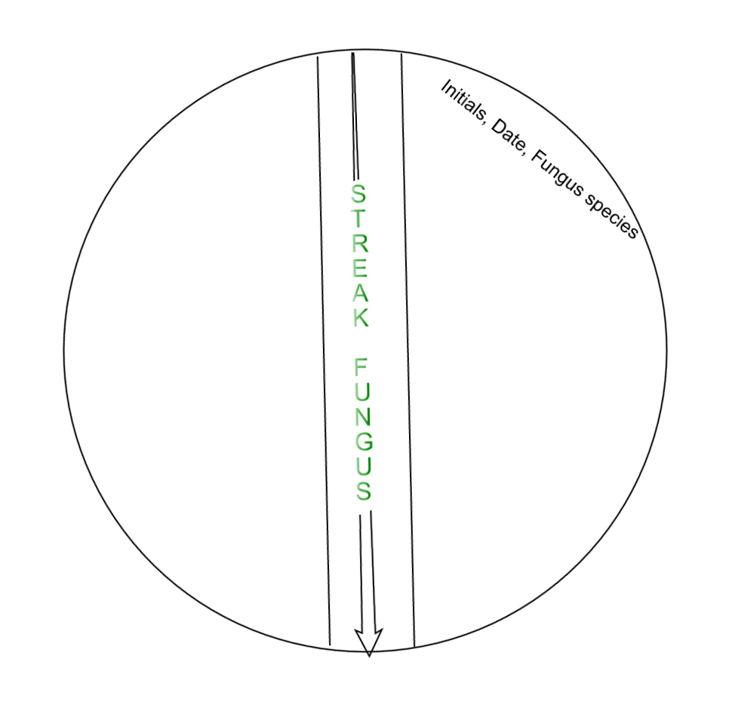

Culturing Bacteria (DAY 1 continued)

You will grow three different bacteria to test against the antibacterial effect of P. crysogenum. Because each bacteria have different doubling times, they grow at very different rates. You will need to begin growing the slowest growing bacteria (Staphylococcus epidermidis) and (Micrococcus luteus) today and the third (Enterobacter aerogenes) the next day.

- Pipette 3ml LB broth in a culture tube to grow bacterial species.
  - Label the culture tube containing 3ml LB: S. epi.
  - Using sterile technique, attach a sterile 20 – 200ul pipette tip to a p20 or p200 pipette.
  - Collect ~1mm³ or 1-2 colonies of bacteria from the S. epidermidis plate at the end of the pipette tip.
  - Eject the tip using the ejector button on the pipette into the S. epi labeled culture tube containing 3ml LB broth.

- Pipette 3ml LB broth in a culture tube to grow bacterial species.
  - Label the culture tube containing 3ml LB: M. luteus .
  - Using sterile technique, attach a sterile 20 – 200ul pipette tip to a p20 or p200 pipette.
  - Collect ~1mm³ or 1-2 colonies of bacteria from the M. luteus plate at the end of the pipette tip.
  - Eject the tip using the ejector button on the pipette into the M. luteus labeled culture tube containing 3ml LB broth.

- Incubate your tubes with the rest of the class by shaking at 180 rpm overnight at room temperature.

Culturing Bacteria (DAY 3)

- Pipette 3 ml LB broth in a culture tube to grow E. aero.
  - Label the culture tube containing 3ml LB: E. aero.
  - Using sterile technique, attach a sterile 20 – 200ul pipette tip to a p20 or p200 pipette.
  - Collect ~1mm³ or 1-2 colonies of bacteria from the E. aero plate at the end of the pipette tip.
  - Eject the tip using the ejector button on the pipette into the E. aero labeled culture tube containing 3ml LB broth.

- Incubate your tube with the rest of the class by shaking at 180 rpm overnight at room temperature.

Co-cultivation (DAY 4)

The cultures are ready to be co-cultivated. (bacteria added to fungus)

- Determine the relative bacteria concentration by measuring OD600 of your overnight bacterial culture from the 3mL LB culture tubes.
  - Blank the spectrophotometer with 900μl LB in a cuvette.
  - Make sure your S. epidermidis is well mixed by pipetting up and down with a p1000 set to 1ml.
  - Pipette 100μl of bacteria into the cuvette containing 900μl LB and pipette up and down to mix.
  - Measure OD600 and record value for Spec Reading and Actual OD (Spec Reading times 10 = Actual OD)
  - Repeat steps a-d with your M. luteus, and E. aerogenes 3ml cultures.
  - Record your results in table 2. You are looking for an OD between 1-3.

Table 2: Bacterial overnight culture optical density data

Bacterial Species | Spec Reading | Actual OD600
S. epidermidis
M. luteus
E. aerogenes

If the OD of one or two of your cultures is higher than the other(s), then dilute the higher so that its concentration is close to the concentration of the other(s).

For example: If your E. aerogenes OD is 3 and S. epidermidis and M. luteus are close to 2, then dilute E. aerogenes to 2 using C₁V₁ = C₂V₂. C₁ is the OD of E. aerogenes (7.5), V₁ is the volume in the culture tube, now 2.9ml since you used 0.1 ml for the OD measurement, C₂ is the concentration you would like E. aerogenes to be (2) and V₂ is the volume the culture will need to be diluted to, which is 4.35ml.

(3) x 2.9ml = (2) x V₂ V₂ = 4.35ml Therefore you will need to add 1.45ml to the 2.9ml culture to bring the volume to 4.35ml and the OD to 2.

- The last step is to inoculate bacteria on the vertical stripped
P. crysogenum LB agar plate you made on day 1.

  - Using sterile technique, dip a sterile inoculating loop into the
S. epidermidis bacterial culture.
  - Make two stripes starting at the edge of the plate perpendicular to the fungus moving the loop toward the fungus.
  - Label with the bacteria name just under the stripes.
  - Repeat steps 20a – 20c using the other bacteria. You can use both sides of the fungal stripe.
  - Incubate at room temperature overnight.

Measuring the vertical stripe plates.

- Using a ruler, measure the distance from the vertical stripe of fungus to the first sign of bacteria in the bacterial stripes. Do this for each of the bacteria on your plate.

- Record any observations and differences you can see. Focus on the way the bacteria are growing. How are they different from each other?

